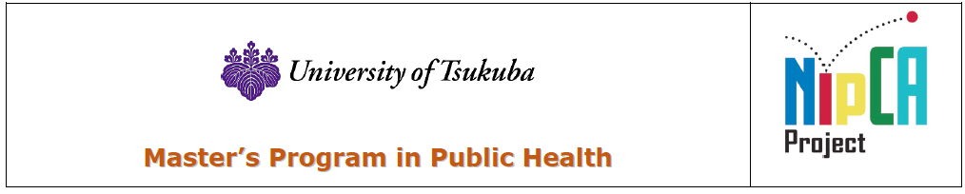
The Nippon Foundation Central Asia- Japan Human Resource Development Project (NipCA) Fellowship Program Preliminary Application Form
Personal Information
1. | Name (as in passport)  First Middle Last
2. | Citizenship
3. | Passport Details  Number Issuing country Issuing place  Issuing authority Date of issue (Year/Month/Date) Date of expiration (Year/Month/Date)
4. | Date of Birth (Year/Month/Date) | 5. | Place of Birth | 6. | Sex  Male ☐ Female ☐
7. | Marital Status  Single ☐ Married ☐ | 8. | Current Position
9. | Address (Permanent)  Phone(+Country code):  +  Email: | Address (Present)  Phone(+Country code):  +  Email: |  | Mailing Address  ☐ Permanent Address  ☐ Present Address  ☐Other Address below
10. | Accompanying persons, if any Yes ☐ No ☐ (If the answer is “yes”, provide the following information)
 | Name | Date of birth (Year/Month/Date) |  | Relationship
11. | Past entry into/stay in Japan (Year/Month/Date) (Year/Month/Date)  ☐ Yes ( ) Time(s) Latest entry from _______________________ to ______________________  ☐ No

Language Competency
12. | Mother Tongue:
13. | Other Languages Proficiency
 | 1) English |  | Written |  |  |  | Oral |  |  |  | Listening |  |  |  | Speaking
 |  |  | Excellent | ☐ |  |  | Excellent |  | ☐ |  | Excellent |  | ☐ |  | Excellent |  | ☐
 |  |  | Good | ☐ |  |  | Good |  | ☐ |  | Good |  | ☐ |  | Good |  | ☐
 |  |  | Fair | ☐ |  |  | Fair |  | ☐ |  | Fair |  | ☐ |  | Fair |  | ☐
 |  |  | Poor | ☐ |  |  | Poor |  | ☐ |  | Poor |  | ☐ |  | Poor |  | ☐
 | 2) __________ |  | Written |  |  |  | Oral |  |  |  | Listening |  |  |  | Speaking
 |  |  | Excellent | ☐ |  |  | Excellent |  | ☐ |  | Excellent |  | ☐ |  | Excellent |  | ☐
 |  |  | Good | ☐ |  |  | Good |  | ☐ |  | Good |  | ☐ |  | Good |  | ☐
 |  |  | Fair | ☐ |  |  | Fair |  | ☐ |  | Fair |  | ☐ |  | Fair |  | ☐
 |  |  | Poor | ☐ |  |  | Poor |  | ☐ |  | Poor |  | ☐ |  | Poor |  | ☐
14. | Language Proficiency Tests  Test Name Score Date taken  Test Name Score Date taken
Educational Background
16. | Total years of education (from elementary school to the last institution of education). ( )years
 | University or equivalent (Name, place, and country) |  |  |  |  | Attended |  |  |  |  |  | Degrees and Academic Distinctions Obtained |  |  |  | Faculty, Department, or Major Course of Study
 |  |  |  |  |  | From Month/Year |  | To Month/Year
17 | Schools or other formal training or education from first year elementary school (include elementary school, secondary school, and high school)
18. | List of Publications (if any)
Employment History
19. | Starting with your present post, please list the most recent employment experience in reverse order (New to OLD). Use a separate line for each post. Include service in the armed forces and note any period during which you were not gainfully employed. If you need more space, attach additional pages of the same size.
 | Date |  |  |  | Name of Employer |  |  |  |  | Exact Title of Your Post |  |  |  | Brief Description of Your Duties
 | From | To

Statement of Purpose (Motivation Letter)
20. Brief Statement of Purpose (No more than 1000 words in total).
* Please include the following points: 1) Your research interest and how it is related to SDGs; 2) Reasons for applying to the MPH program and the NipCA fellowship at the University Tsukuba, 3) Future career vision.

